|  |  |
| --- | --- |
|  | FPT ACADEMY INTERNATIONAL  FPT – APTECH COMPUTER EDUCATION |

Centre Name: ACE-HCMC-2-FPT.

Address: 590 Cach Mang Thang 8, District 3, Ho Chi Minh City, Viet Nam.

**Rock Paradise**

|  |  |  |
| --- | --- | --- |
| Supervisor: | Phạm Thị Lánh | |
| Term: | 1 | |
| Batch No: | T1.2212.E1 | |
| Group No: | 4 | |
| Order: | Full name | Roll No. |
| 1. | Nguyễn Hữu Cường | Student1438974 |
| 2. | Lê Thanh Bảo Phú | Student1438982 |
| 3. | Huỳnh Văn Lời | Student1352176 |
| 4 | Phạm Đăng Khoa | Student1387837 |

Month 04 Year 2023

This is to certify that

**Mr. NGUYỄN HỮU CƯỜNG**

**Mr. LÊ THANH BẢO PHÚ**

**Mr. HUỲNH VĂN LỜI**

**Mr. PHẠM ĐĂNG KHOA**

Have successfully Designed & Developed

**ROCK PARADISE**

Submitted by: **Ms. PHAM THI LANH**

Date Of Issue: April, 2023

# Content

Content 3

Acknowledge 5

Synopsis 6

REVIEW 1 7

Problem Definition 8

Customer Requirements Specifications 9

Architecture and Design of the project 10

Site map 11

Website Design Layout 12

I. Homepage 12

II. Sign in 14

III. Sign up 14

IV. Sales 15

V. Product Category/Search Page 16

VI. Product Comparison 17

VII. Product Detail 18

VIII. Cart Dropdown 19

IX. Check out 20

X. Contact 22

XI. About 24

Task Sheet 25

REVIEW 2 26

WEBSITE USER INTERFACE 27

I. Homepage 27

II. Sign in 29

III. Sign up 30

IV. Sales 30

V. Product Category/Search Page 32

VI. Product Comparison 33

VII. Product Detail 34

VIII. Cart Dropdown 35

IX. Check out 36

X. Contact 37

XI. About 38

Task Sheet 40

Testing document 41

Final checklist 42

# Acknowledge

The eProject is an innovative learning platform that emulates the traditional classroom and lab-based learning environments, offering a practical and hands-on approach to learning. With this platform, participants can develop their skills step-by-step using a laddered approach, building larger and more robust applications, and gaining experience in the usage of utilities in the applications they design.

The eProject provides a unified code that leads to the development of complete applications, allowing participants to implement concepts in a phased manner and enhance their skills, adding value to their knowledge base. This platform offers the opportunity to work on real-life projects, providing participants with a realistic scenario to create complex and useful applications.

Moreover, participants have access to email support for mentoring throughout the eProject, ensuring that they receive the guidance and assistance they need to achieve their goals.

We express our sincere gratitude to our professor and fellow students for their invaluable support during this project. Despite encountering some challenges, we appreciate the opportunities that this project has provided us to expand our knowledge and skills in the web development world. We are particularly grateful to India APTECH for sharing their demo project, which has given us a more realistic experience in this project.

Through this eProject, we have gained valuable experience and will continue to learn and improve our skills to become successful in our future endeavors. Thank you for this excellent opportunity.

Sincerely,

Team Group 04.

# Synopsis

The primary objective of this program is to provide participants with an opportunity to gain practical experience in developing real-life projects. By working on sample projects, participants will be able to build a more comprehensive and robust understanding of the tools and technologies used in modern application development. While the program covers topics such as HTML and JavaScript, the primary goal is not to teach these technologies per se, but to provide a real-life scenario that participants can apply their knowledge and skills to.

Through this program, participants will gain valuable experience in creating basic applications using the tools and technologies they have learned. They will be given the opportunity to review relevant topics before commencing the project, ensuring that they have a solid foundation to build upon. The aim is to provide participants with a realistic, hands-on experience that they can take with them into their future careers.

It is important to note that this program is designed for students who have completed the HTML5 module. Participants are expected to have a solid understanding of the underlying principles of HTML and web development. While faculty assistance will be provided as required during lab sessions, it is essential that participants have a clear understanding of the subject matter to get the most out of the program.

The website that participants will create during this program serves as a valuable tool for the company, allowing them to access the international market and attract new customers. By working on a real-life scenario, participants will gain a better understanding of the challenges that companies face when developing applications for a global audience.

In summary, this program provides participants with a valuable opportunity to gain practical experience in developing real-life projects. By working on sample projects and applying their knowledge and skills to a real-life scenario, participants will build a more comprehensive and robust understanding of the tools and technologies used in modern application development. This program is designed for students who have completed the HTML5 module, and faculty assistance will be provided as required during lab sessions. Ultimately, the aim is to provide participants with a realistic, hands-on experience that they can take with them into their future careers.

**Activity of the members**

**MOST IMPORTANT!!!**

* **the result of each member's work:**

|  |  |
| --- | --- |
| **Members** | **Percent working** |
| Nguyễn Hữu Cường | 99% |
| Lê Thanh Bảo Phú | 1% |
| Huỳnh Văn Lời | 0% |
| Phạm Đăng Khoa | 0% |

# REVIEW 1

# Problem Definition

Rock Paradise is a store that specializes in crystals and gemstones. With the growing demand for online shopping, they are looking to establish their presence on the internet. To achieve this, they need a website that showcases their products in an organized manner, making it easy for customers to view and purchase the right product to meet their needs.

The website will be designed to display the various crystals and gemstones available at the store, including product details and pricing. Additionally, the website will feature a GeoLocation API (e.g., GoogleMaps) to provide customers with information on store locations. Feedback mechanisms will also be incorporated to allow customers to leave reviews and ratings for products they have purchased.

The website will be developed using HTML5, JavaScript, and Geolocation, ensuring that it is fully compatible with all leading browsers such as Chrome, IE, Firefox, etc. Several challenges need to be addressed in developing the website, including:

As more customers prefer online shopping, it is crucial to make it easy for them to find the product they need and make a purchase.

Not all customers are aware of the full range of products offered by Rock Paradise, leading to dissatisfaction when products do not meet their requirements or expectations.

Customers rely on reading reviews before purchasing products online, so it is essential to provide a platform for customers to share their experiences and ratings of products.

Existing customers may require assistance after installation, and Rock Paradise can provide support through phone or email. Additionally, many customers may prefer to visit the store to view the product before making a purchase.

The website will address these challenges, providing a seamless online shopping experience for customers while showcasing the full range of products offered by Rock Paradise. With this website, Rock Paradise aims to expand its reach and continue to provide high-quality products and customer service to its valued customers.

## Customer Requirements Specifications

|  |
| --- |
| USER: |
| Input:  ● Input consumer’s address of residence or office  ● Send questions/requests to the company |
| Process:  ● Process consumer’s address data  ● Collect questions/requests sent by consumers |
| Output:  ● Show the store address to consumers  ● Reply to the consumer’s requests/questions |

|  |
| --- |
| WEBMASTER: |
| Input:  ● Control website database, input product information,… |
| Process:  ● Analyse website |
| Output:  ● Website interface, images, forms, …  ● Giving interaction |

|  |
| --- |
| HARDWARE / SOFTWARE REQUIREMENT: |
| Software:   * Frontend: HTML5, CSS, Bootstrap, JavaScript, jQuery, AngularJS, XML * Data Store: JSON files or TXT files * Operating Portal: Windows * Browsers: Edge, Chrome, Mozilla Firefox, Safari |
| Hardware:   * Intel Core i3/i5 Processor or higher * 8 GB RAM or above * Color SVGA * 500 GB Hard Disk space |

## Architecture and Design of the project



## Site map

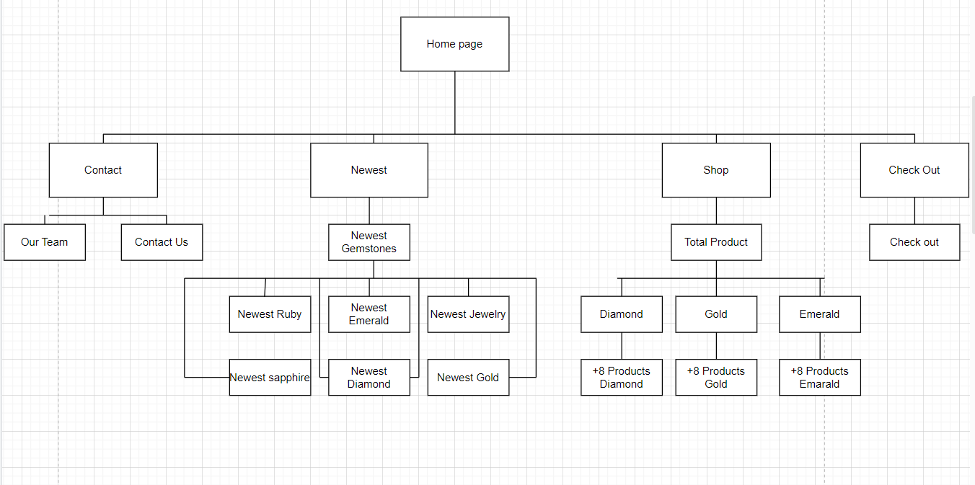

## Website Design Layout

1. Home Page:

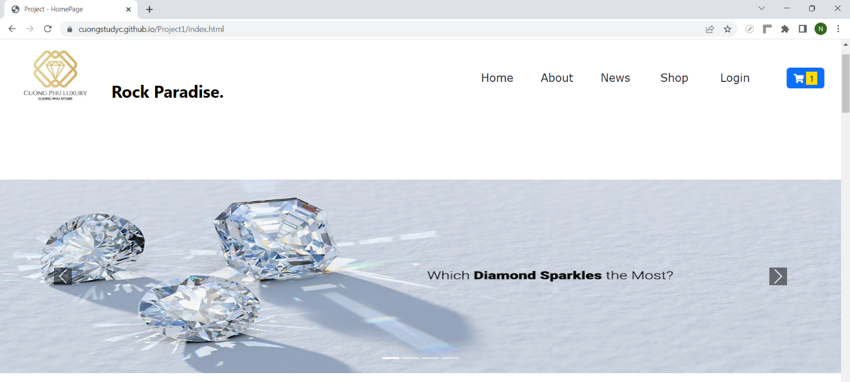

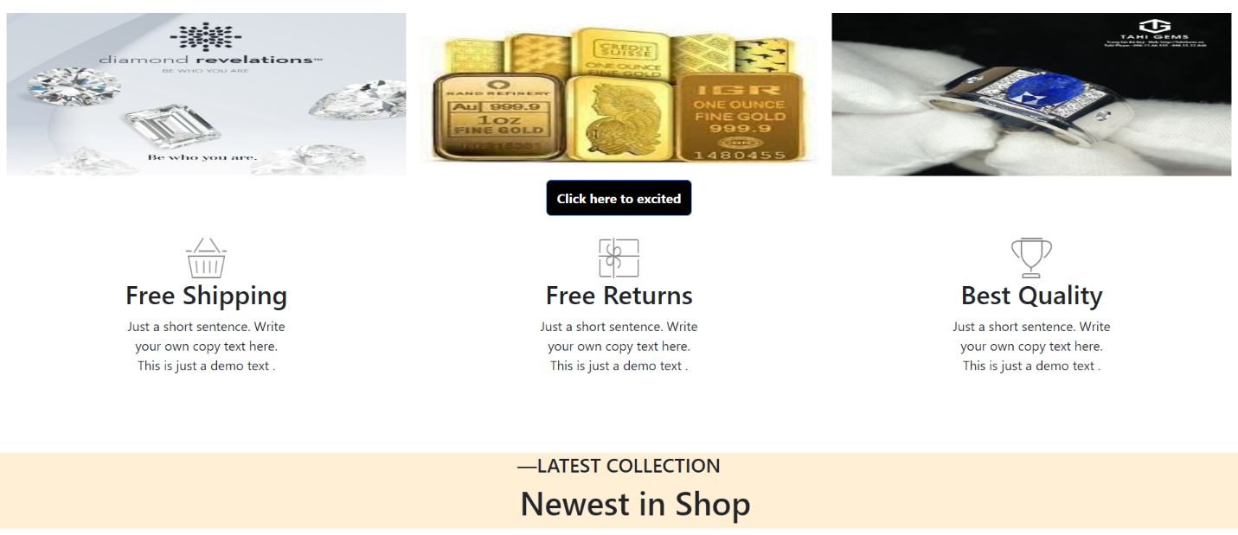

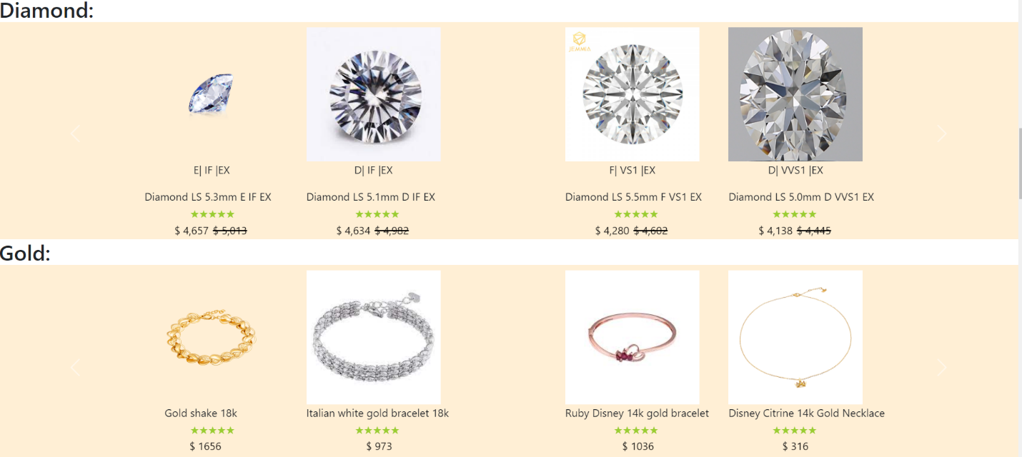

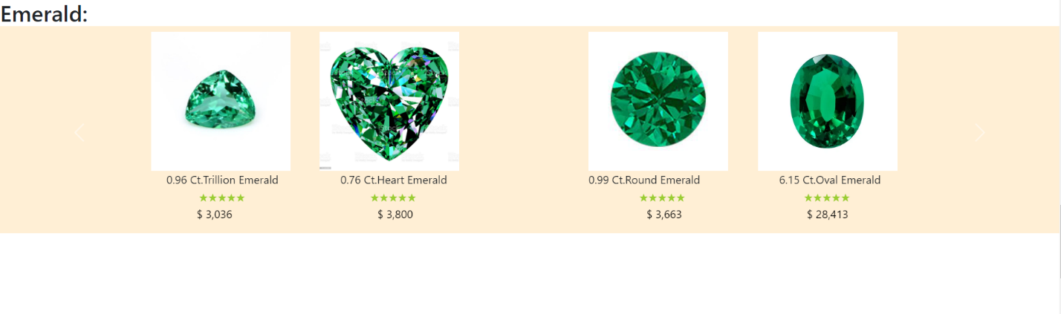

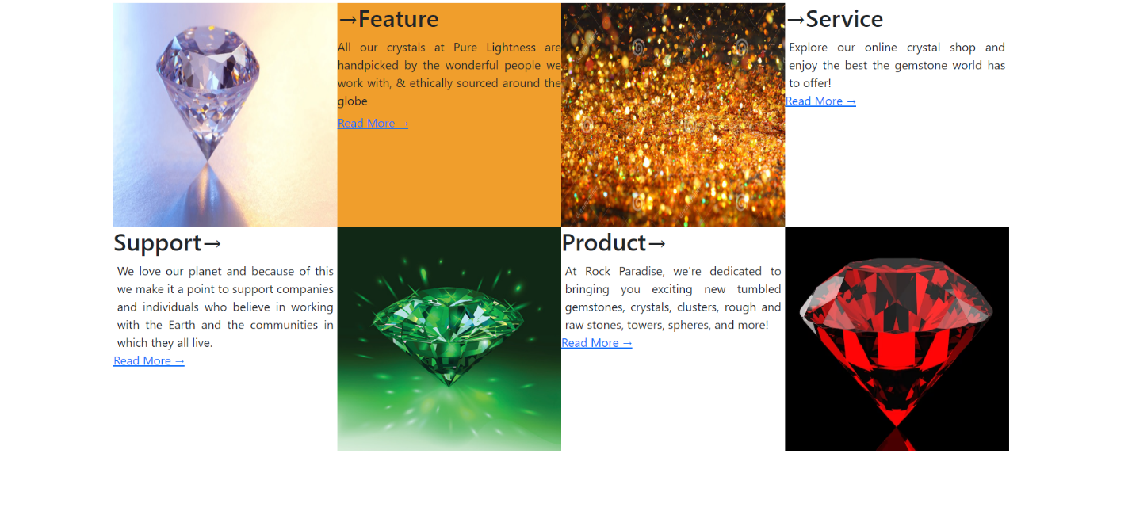

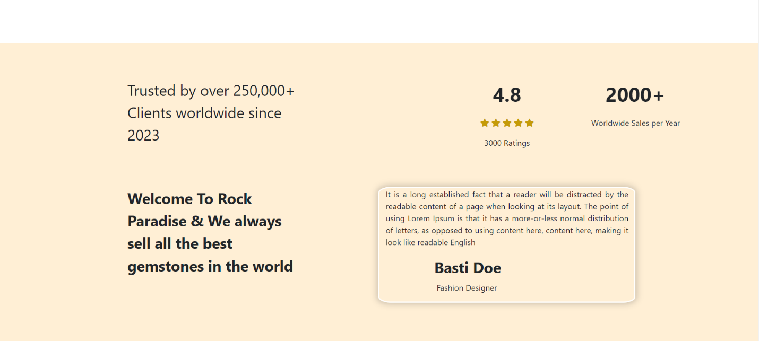

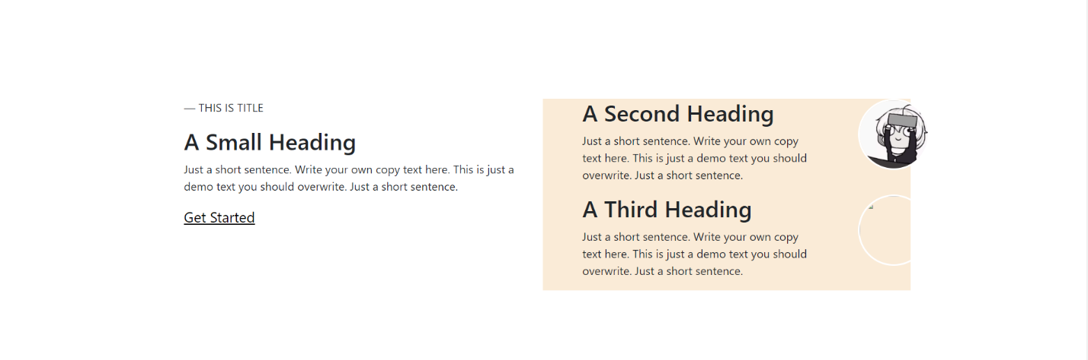

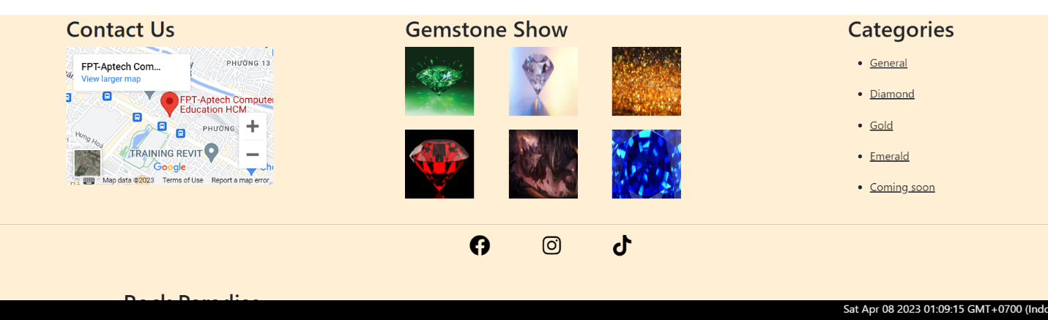

**Description:** This is a homepage of Rock Paradise, the top of this page is a header, after that is a navigation bar. The main part of a homepage beside the slider also includes 3 sections: Lastest Collection: Diamond, Gold, Emerald, Service and Introduce about Gemstones and Crystals, Brand promotion . The footer of a homepage has 4 sections: Summary Contact Us, Gemstones Show, Categories and the last is link connect to Facebook, Instagram and Tiktok. Moreover, the time is always displayed at the bottom of the web page.

1. Contact Us:

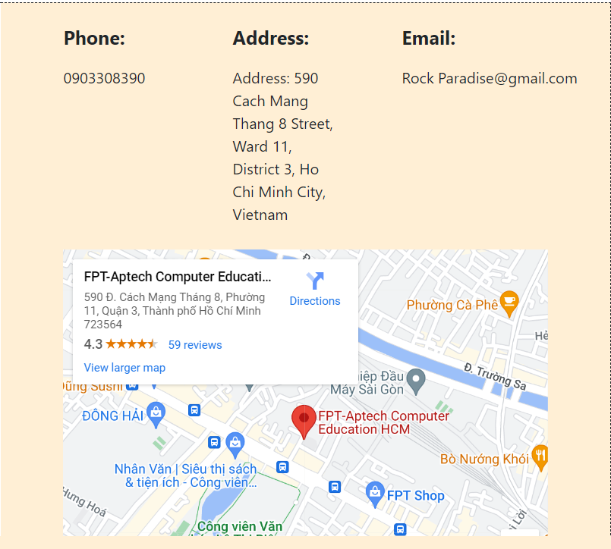

**Description:** After clicking the Contact tag on the navigation bar, the user will be redirected to this page. The first part of this page is a map, beside it is a detailed location of Rock Paradise’s Branches. The last part of this page is a Send information form to send their information to Rock Paradise.

1. News:

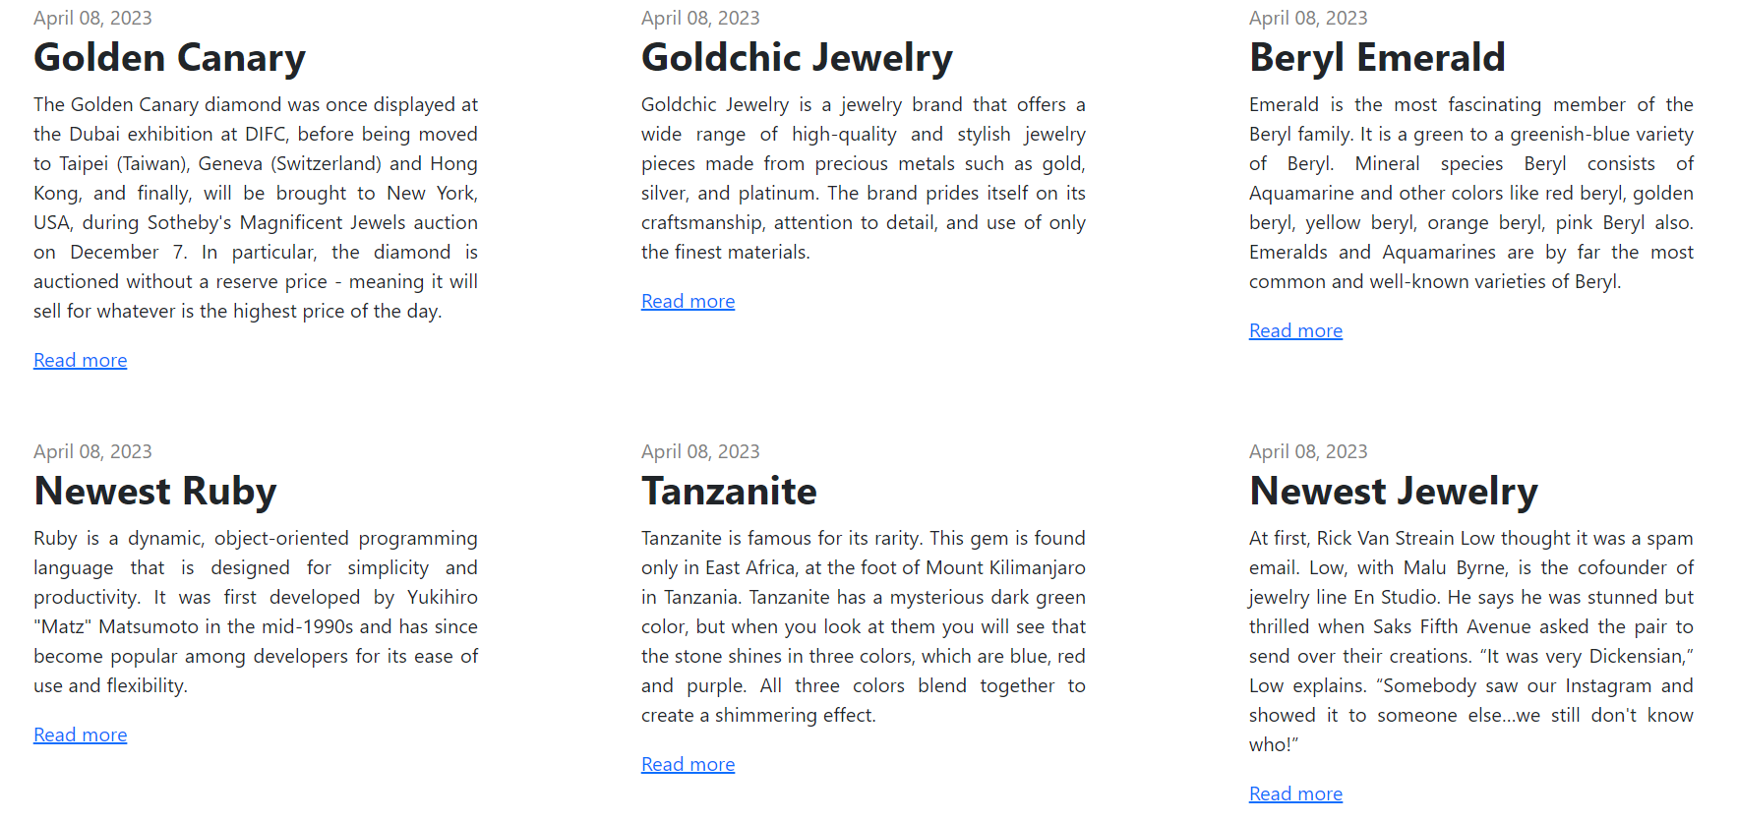

**Description:** New information about gemstones and jewelry

1. Shop:



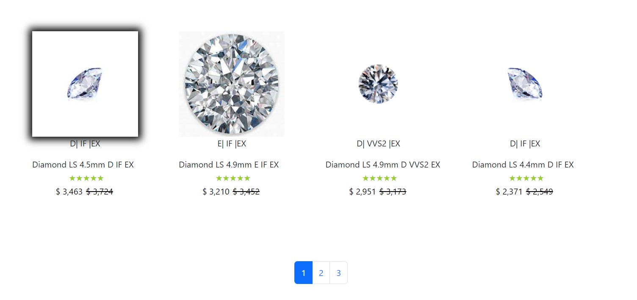

**Description:** ShopTotal includes diamond, gold, emerald, with functions to sort by ascending and descending price, search for gemstones. This page is divided into 3 button page each containing 8 products. Shop Diamond, Gold, Emarld is similar to ShopTotal but each that page not button page and has only 1 type.

1. Cart dropdown:

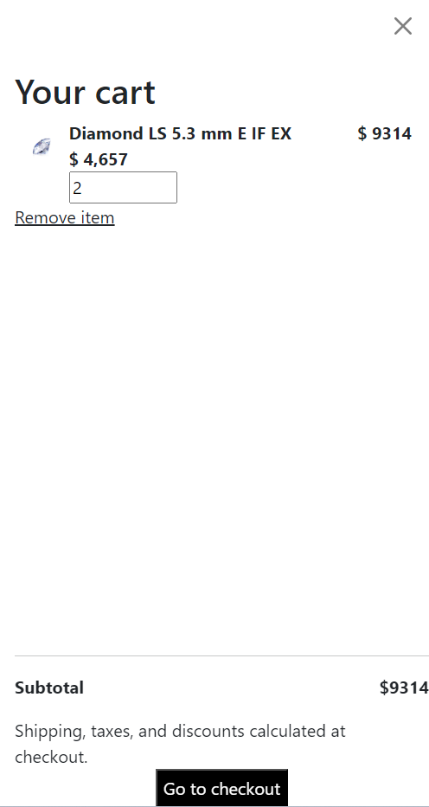

**Description:** When the user clicks on the cart icon in the header, the cart information will appear. It includes products that users have already added to cart, the user can select all items or remove items which they don’t have the intention to buy.

1. Checkout:

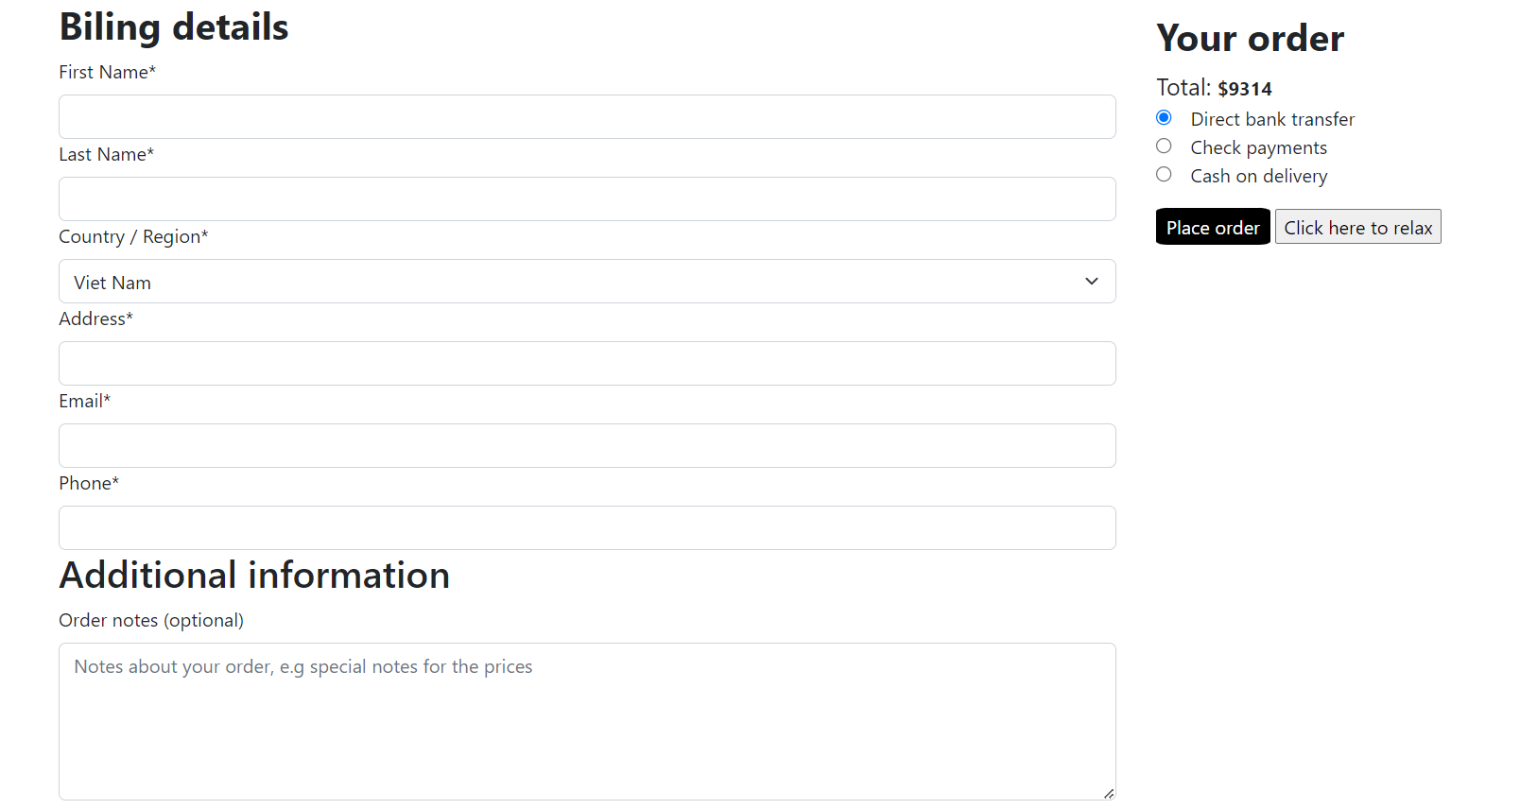

**Description:** After clicking the Check out button on the Cart or Buy now button in Product Detail Page, the user will be redirected to this checkout page. The left part of this page contains a form which requires the user to enter and the other side is the Order summary.

## Task Sheet

|  |  |  |  |  |  |
| --- | --- | --- | --- | --- | --- |
| **Project Ref No.** | **Project Title – Ask Me Mobile** | **Date of preparation of Activity Plan** | | | |
| **Task** | **Actual Start Date** | **Actual Days** | **Performer** | **Status** |
| Brainstorming ideas for layouts and Project Object | | 11/03/2023 | 1 days | Cường | Completed |
| Draw site maps and architecture design | | 12/03/2023 | 1 days | Cường | Completed |
| Wire framing general page layout | | 13/03/2023 | 3 days | Cường | Completed |
| Collect static assets (pictures, mp4, documentation,…) | | 16/03/2023 | 5 days | Cường | Completed |
| Design logic, collect pictures | | 14/03/2023 | 1 day | Phú |  |

# REVIEW 2

# WEBSITE USER INTERFACE

1. Home Page:

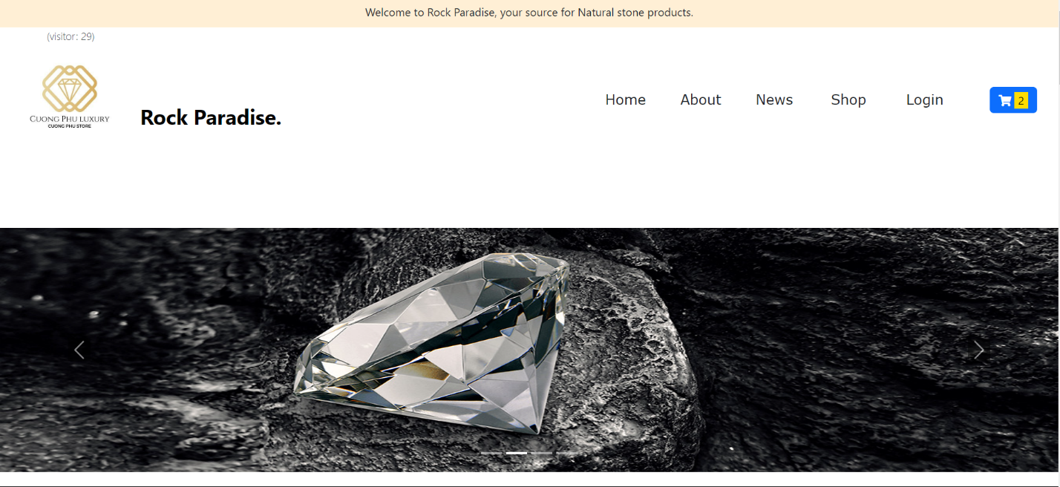

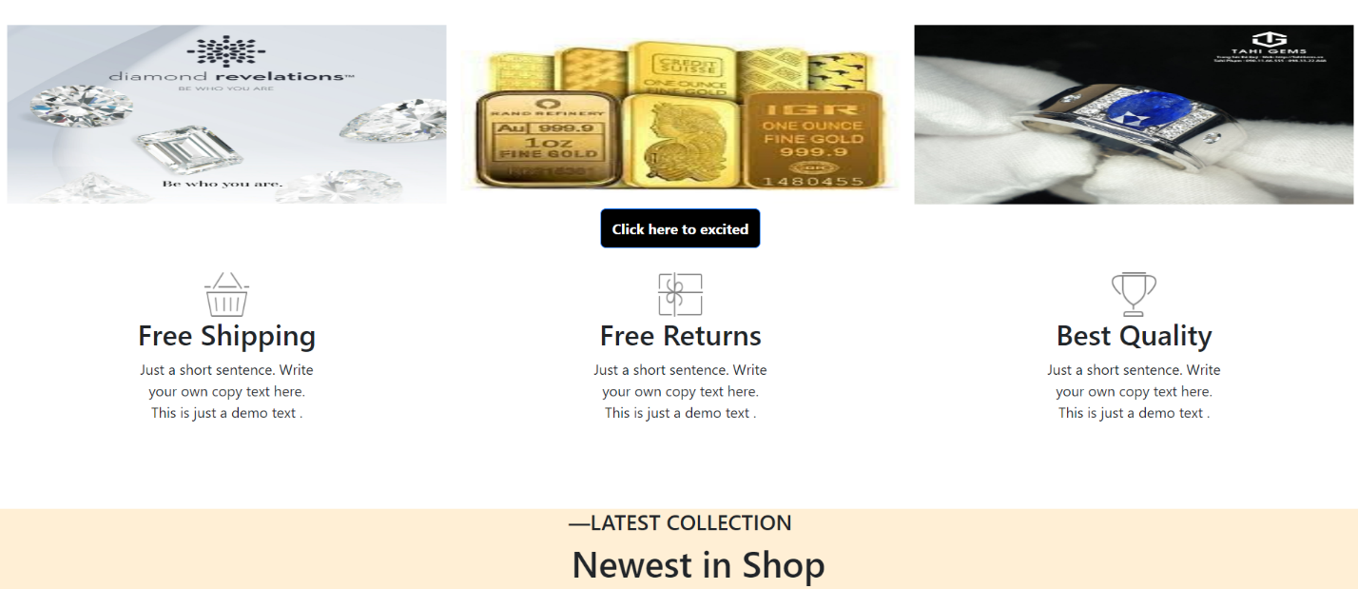

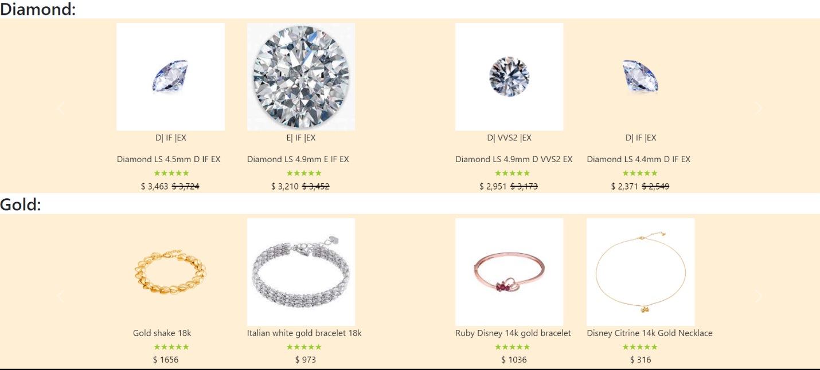

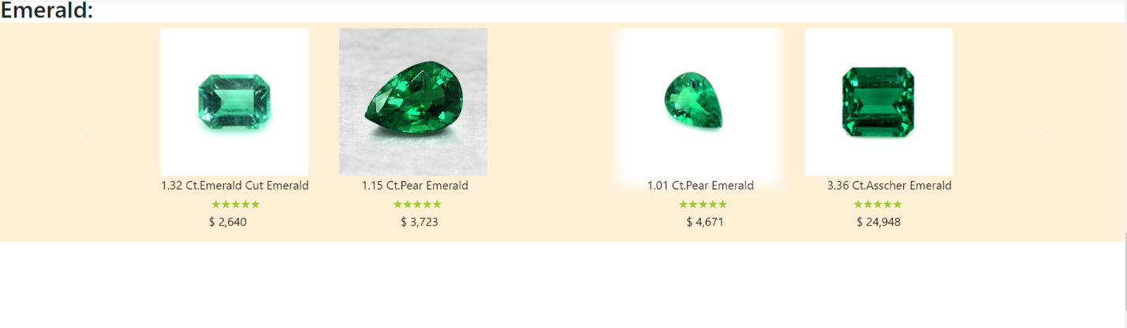

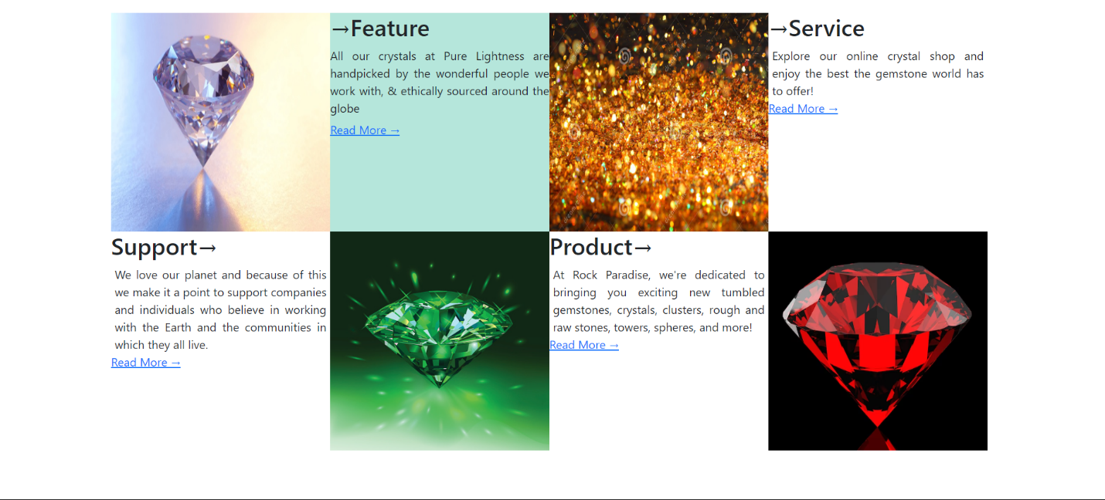

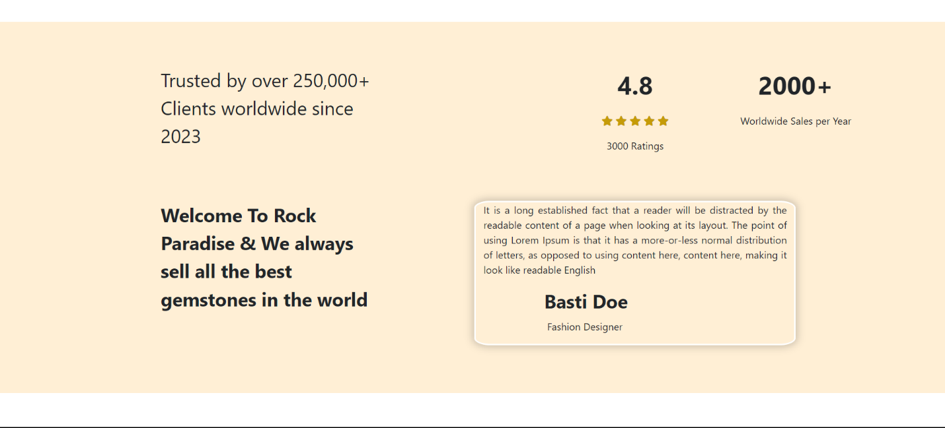

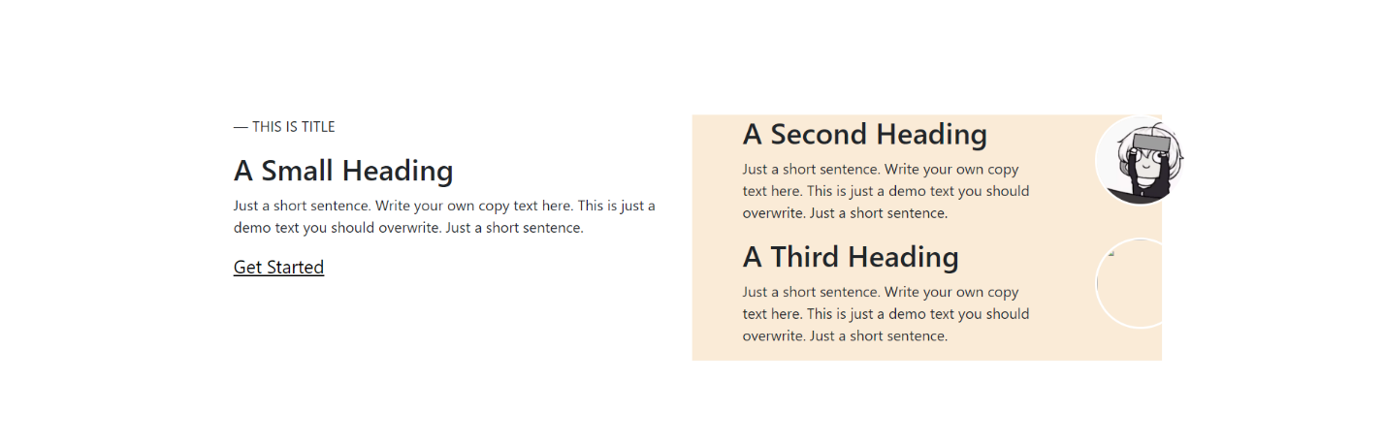

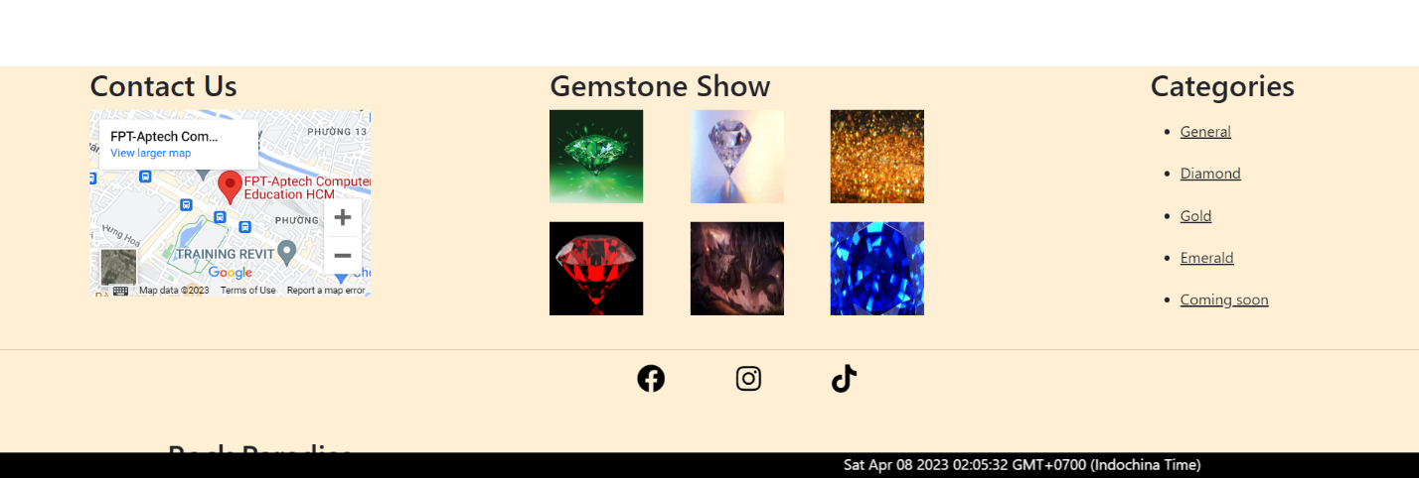

1. About:

+Page 1: Our Team:

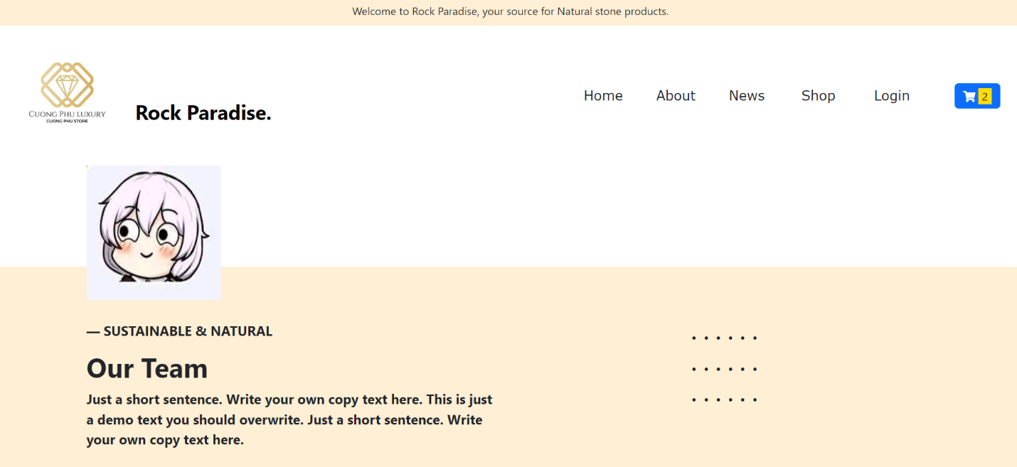

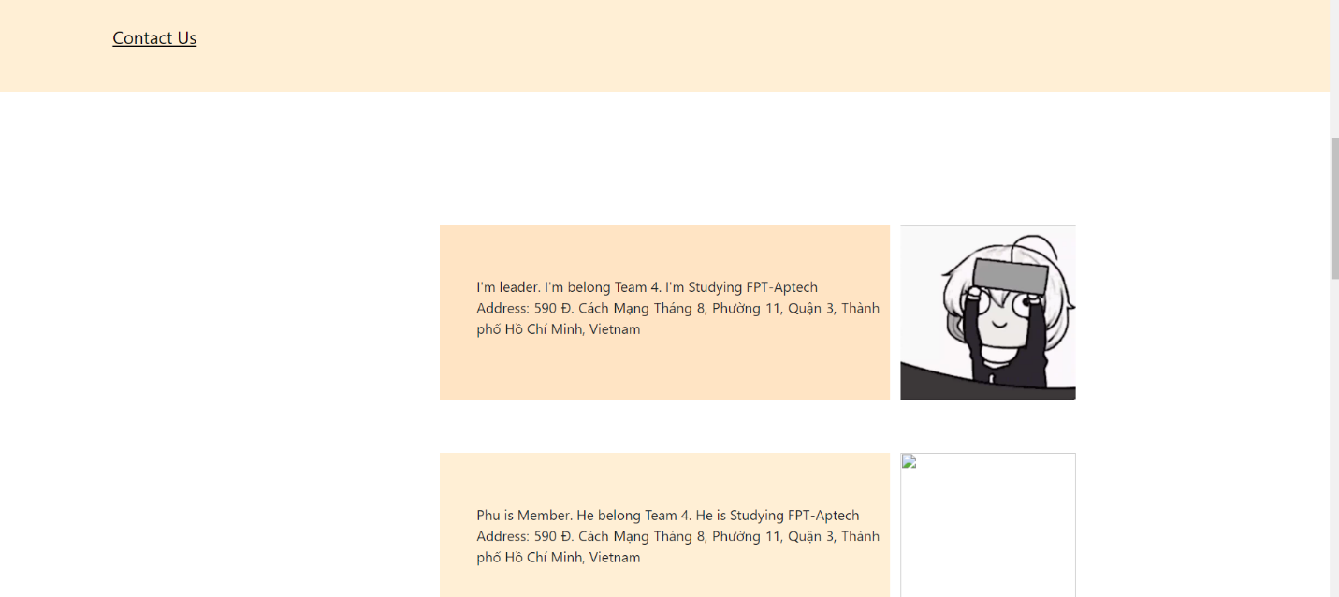

+Page 2: Contact Us:

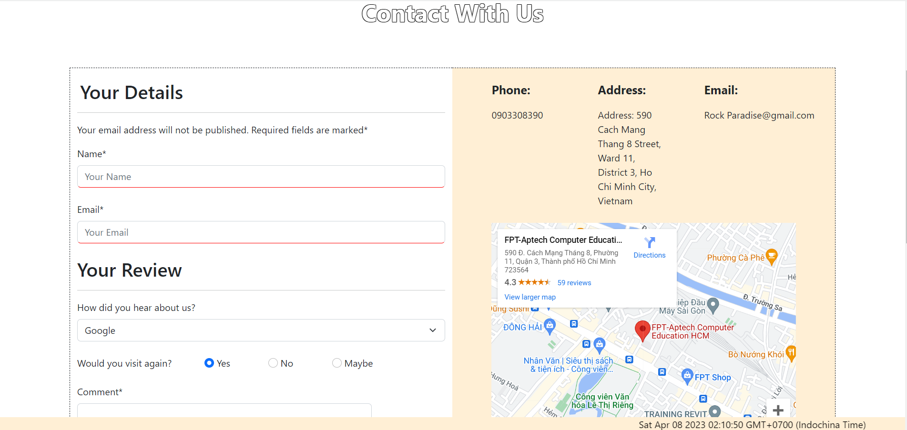

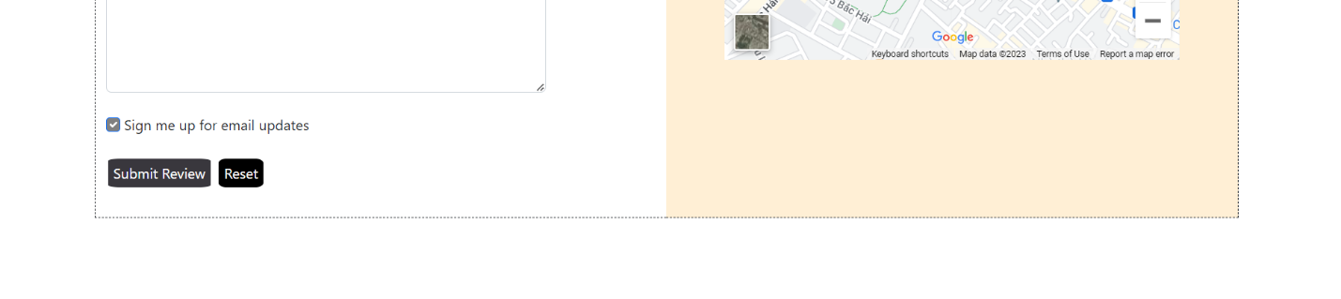

1. New:

+Page Newest GemStones:



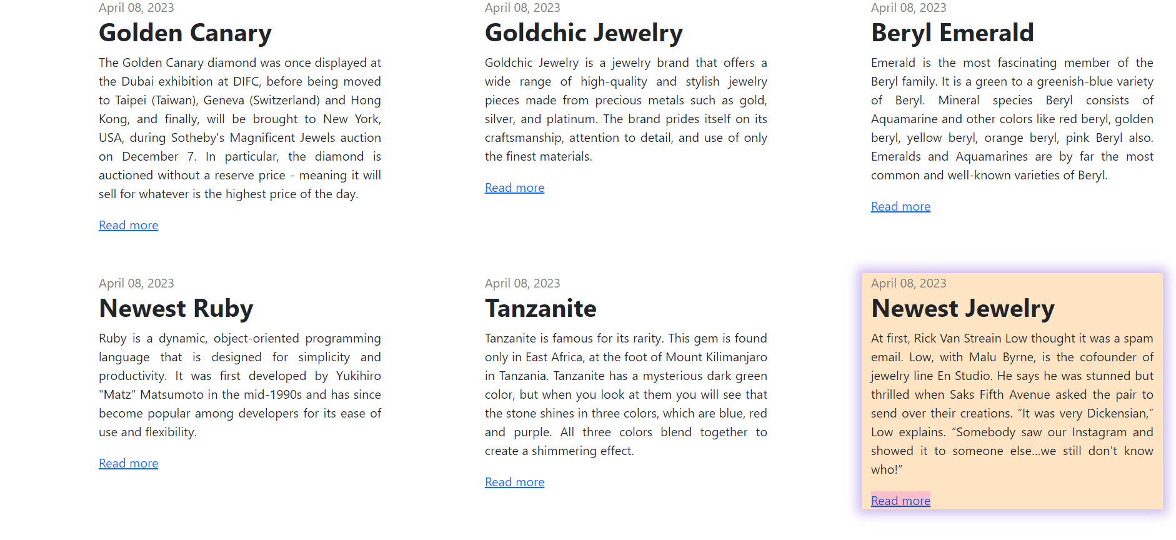

+Page Newest Diamond: This new diamond name is Golden Canary

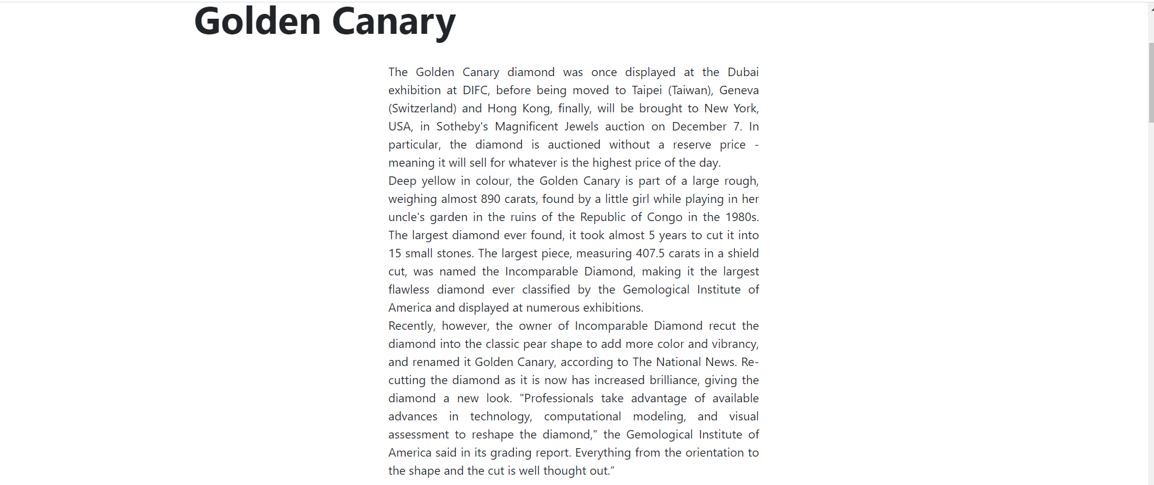



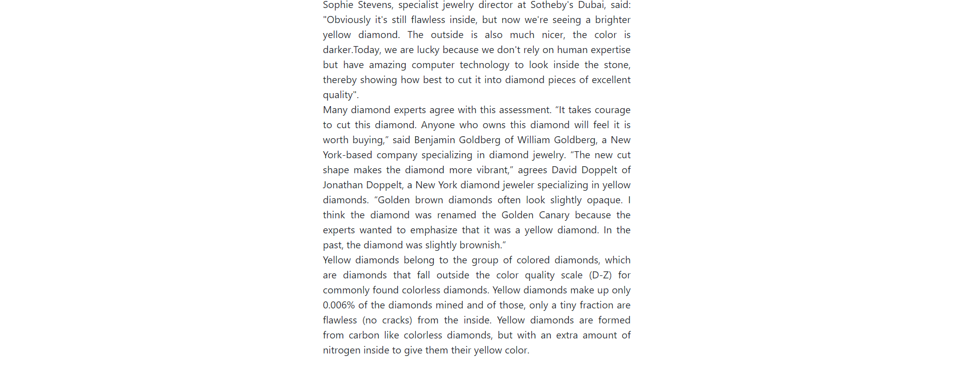

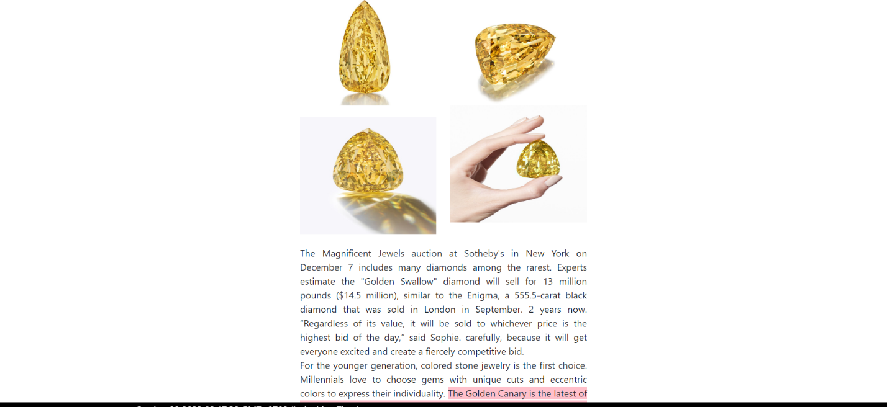



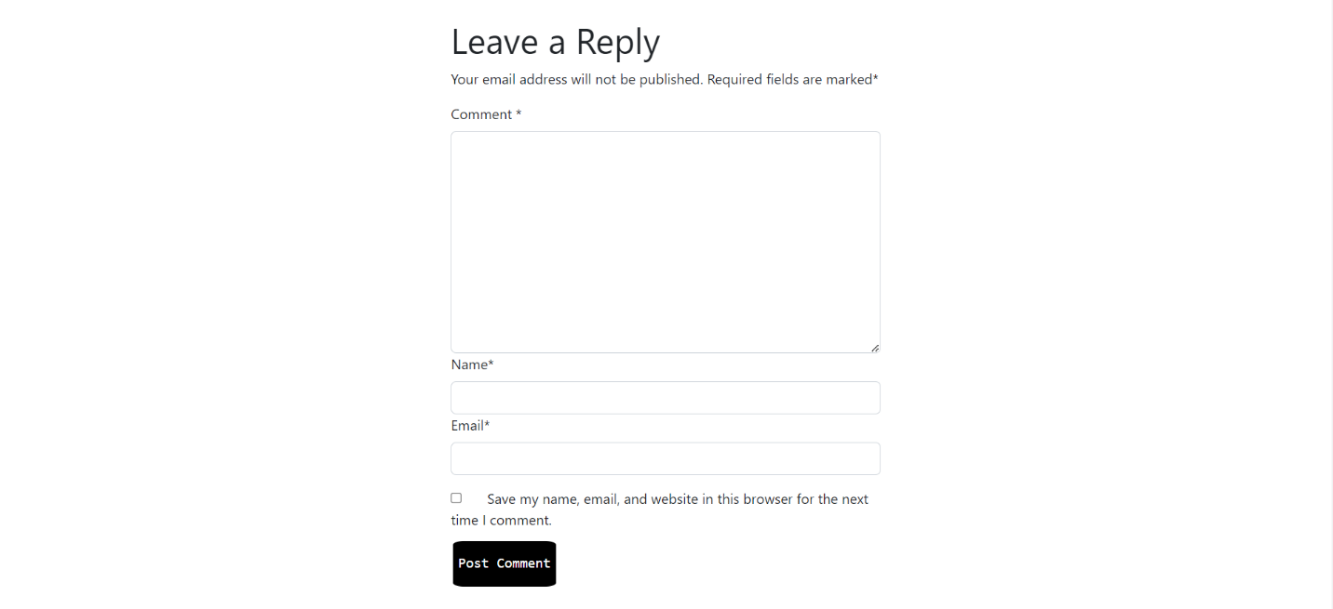

+Other new pages structures are similar to new diamond page.

1. Shop

+Page TotalShop:

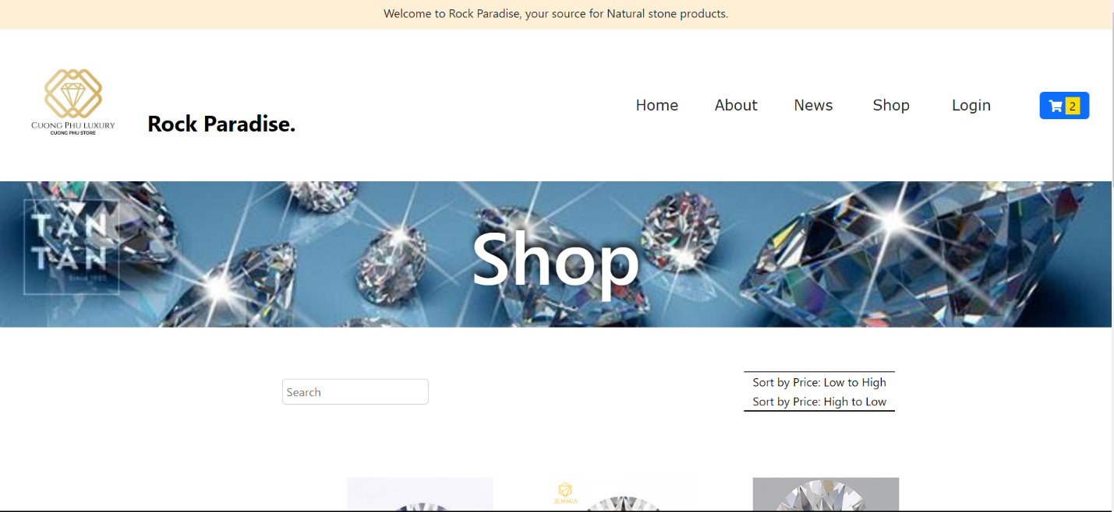

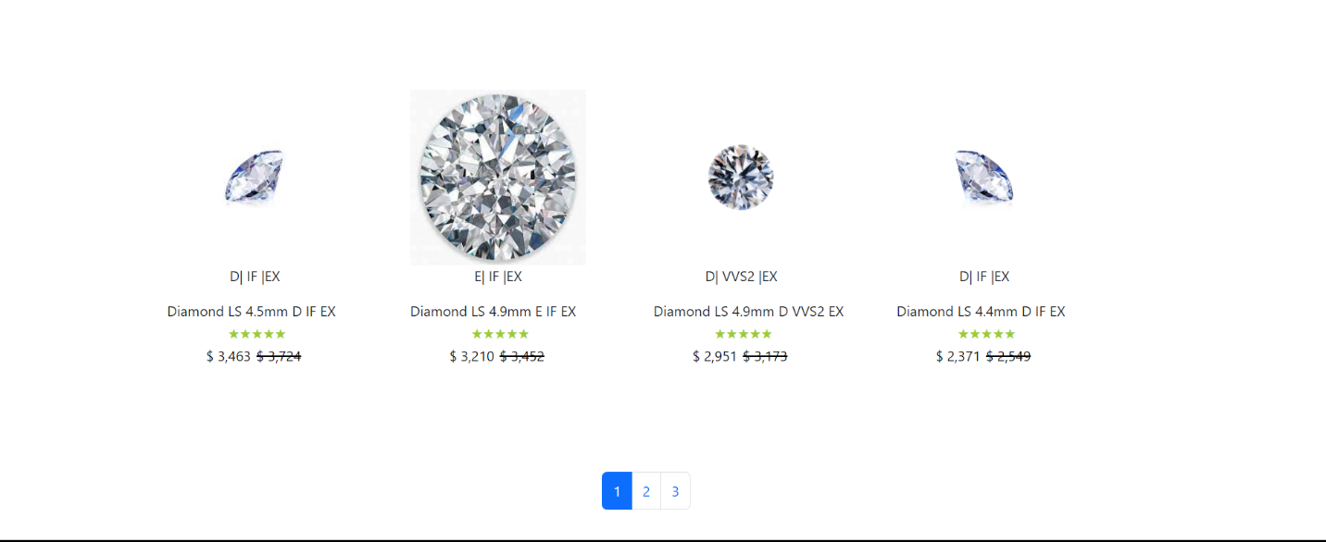

+Page Diamond Shop (Gold Shop and Emerald Shop are similar to Diamond Shop):

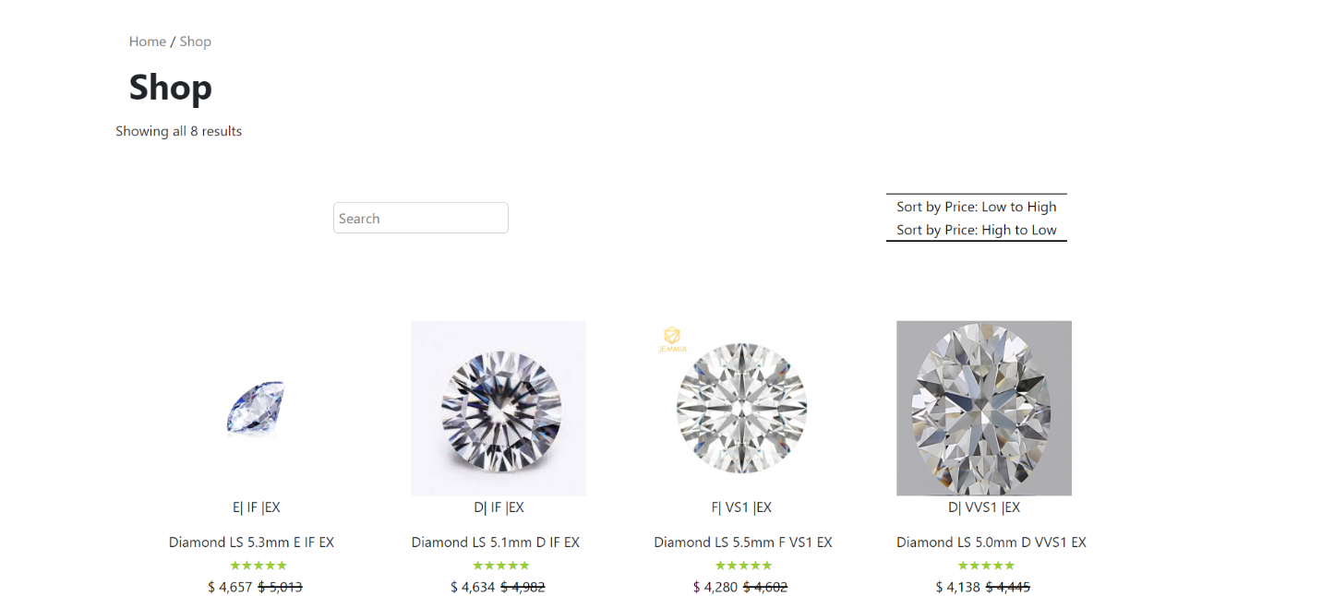

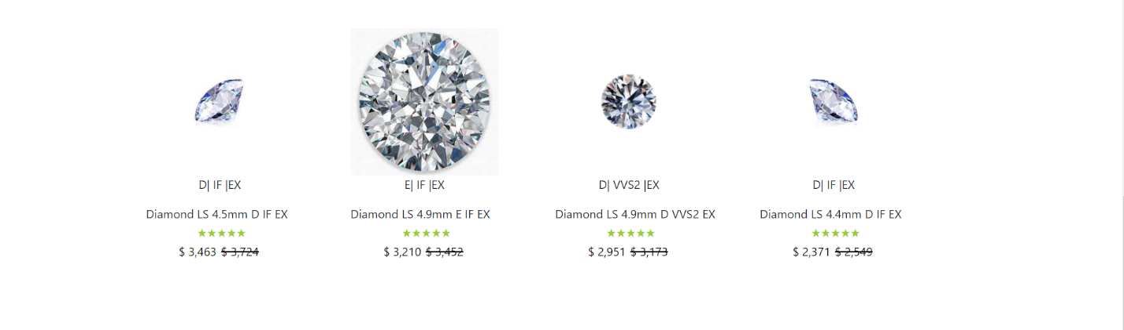

1. Detail Product:

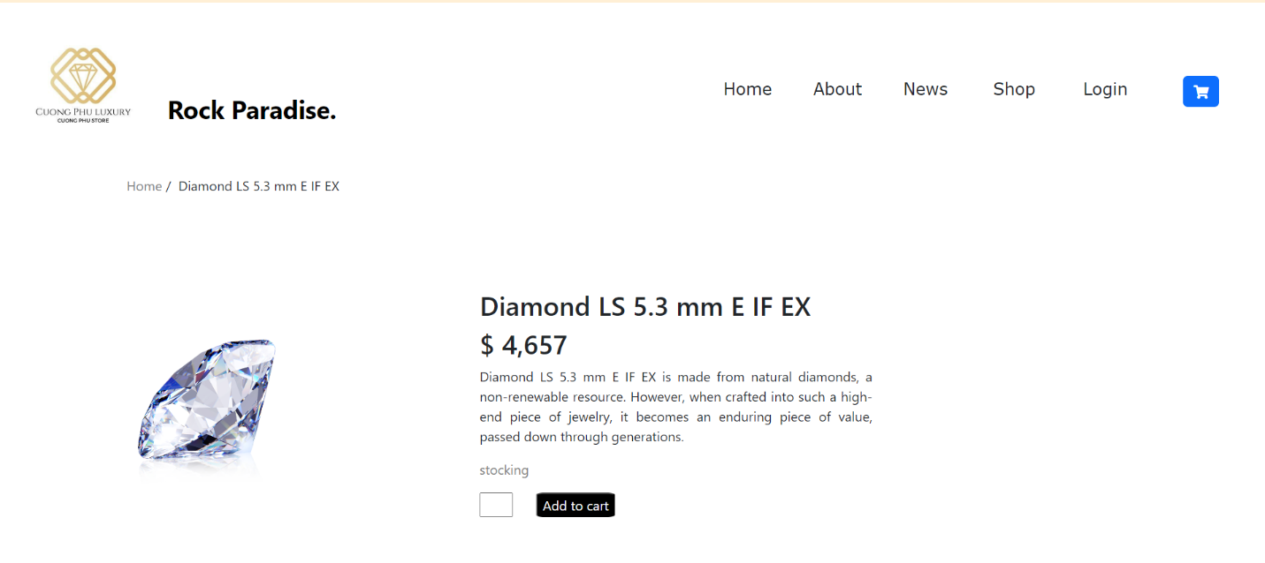

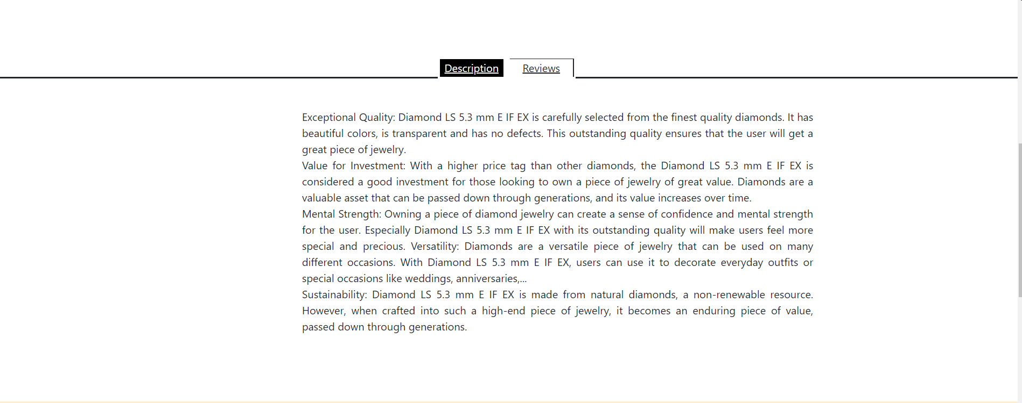

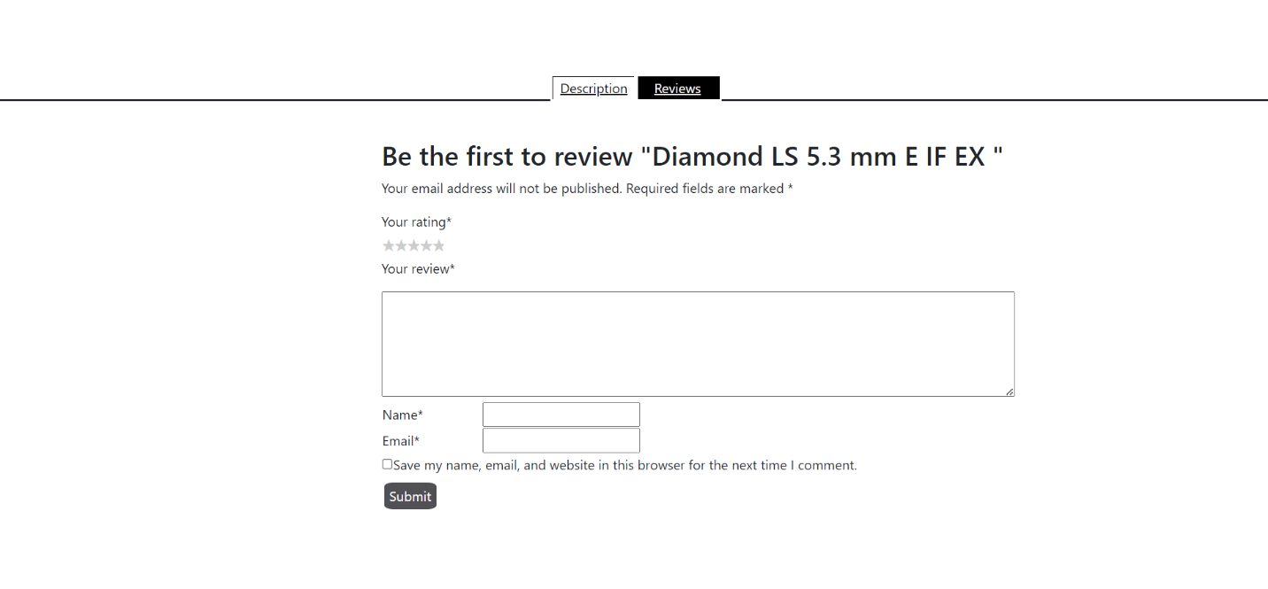

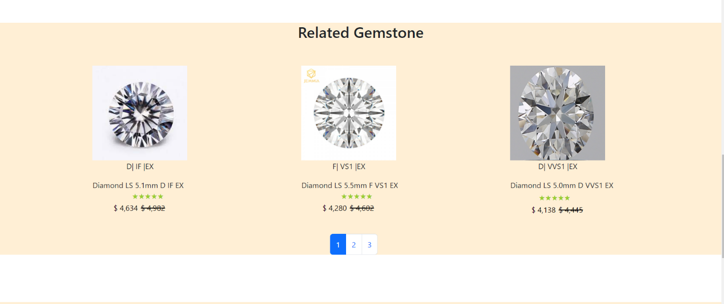

1. Check out:

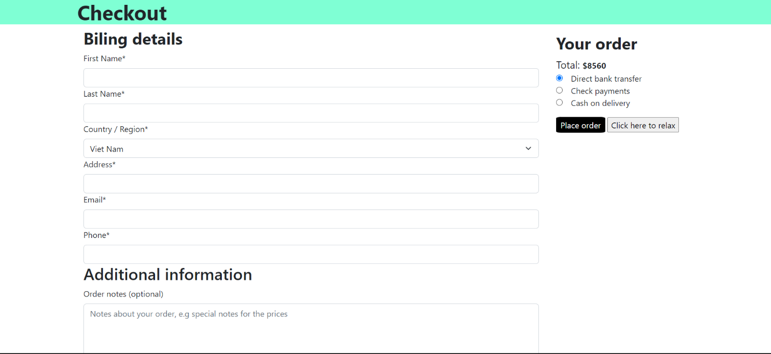

## Task Sheet

|  |  |  |  |  |  |
| --- | --- | --- | --- | --- | --- |
| **Project Ref No.** | **Project Title** | **Date of preparation of Activity Plan** | | | |
| **Task** | **Actual Start Date** | **Actual Days** | **Teammate Names** | **Status** |
| Brainstorming ideas for layouts and Project Object | | 17/03/2023 | 1 days | Cường | Completed |
| Draw site maps and architecture design | | 18/03/2023 | 1 days | Cường | Completed |
| Wire framing general page layout | | 19/03/2023 | 3 days | Cường | Completed |
| Collect static assets (pictures, mp4, documentation,…) | | 22/03/2023 | 5 days | Cường | Completed |
| Design & Build Homepage | | 28/03/2023 | 8 days | Cường | Completed |
| Design & Build About Page | | 29/03/2023 | 1 days | Cường | Completed |
| Design & Build News Page | | 30/03/2023 | 2 days | Cường | Completed |
| Design & Build Product Detail | | 31/03/2023 | 5 days | Cường | Completed |
| Design & Build Cart Dropdown | | 03/04/2023 | 2 days | Cường | Completed |
| Design & Build Check out | | 05/04/2023 | 1 days | Cường | Completed |
| Design & Build Shop Pages | | 06/04/2023 | 2 days | Cường | Completed |
| Product Comparison | | 08/04/2023 | 1 days | Cường | Completed |
| Write Project Report | | 08/04/2022 | 1 days | Cường | Completed |

## Testing document

|  |  |  |  |  |
| --- | --- | --- | --- | --- |
| **Sr.No** | **Features Tested** | | | **Remarks** |
| 1 | Are all the users able to view the images and links? | | | OK |
| 2 | Have all the views, modules and controllers been | |  | OK |
| properly integrated and is the site function as a single | | |
| page application? | |  |
| 3 | Are the GUI content devoid of spelling mistakes? | | | OK |
| 4 | Is the application user-friendly? | | | OK |
| 5 | Is the Website launching correctly in all popular | |  | OK |
| browsers? |  |  |
| 6 | Are all the forms validated with proper criteria? | | | OK |
| 7 | Do all text links lead to the appropriate website? | | | OK |
| 8 | Do all image links lead to the appropriate website? | | | OK |
| 9 | Are all the images and links clearly visible on the page? | | | OK |
| 10 | Does the Web page work properly in all the tested | |  | OK |
| browsers? |  |  |
| 11 | Does the Web page take too long to be loaded fully? | | | OK |
| 12 | Is the navigation sequences correct through all the Web | | | OK |
| pages on the site? | |  |
| 13 | Is the JavaScript code working as expected in all click | | | OK |

## Final checklist

|  |  |  |  |  |
| --- | --- | --- | --- | --- |
| **Sr.No** | **Features Tested** | | | **Remarks** |
| 1 | Are all the users able to view the images and links? | | | OK |
| 2 | Have all the views, modules and controllers been | |  | OK |
| properly integrated and is the site function as a single | | |
| page application? | |  |
| 3 | Are the GUI content devoid of spelling mistakes? | | | OK |
| 4 | Is the application user-friendly? | | | OK |
| 5 | Is the Website launching correctly in all popular | |  | OK |
| browsers? |  |  |
| 6 | Are all the forms validated with proper criteria? | | | OK |
| 7 | Do all text links lead to the appropriate website? | | | OK |
| 8 | Do all image links lead to the appropriate website? | | | OK |
| 9 | Are all the images and links clearly visible on the page? | | | OK |
| 10 | Does the Web page work properly in all the tested | |  | OK |
| browsers? |  |  |
| 11 | Does the Web page take too long to be loaded fully? | | | OK |
| 12 | Is the navigation sequences correct through all the Web | | | OK |
| pages on the site? | |  |
| 13 | Is the JavaScript code working as expected in all click | | | OK |